PROJECT REPORT

1. INTRODUCTION

1.1 Project Overview:

In this project, it organize information about job seekers and makes it searchable. As its name implies, an ATS tracks candidates through the hiring process.

We created a application, they are

* Job application
* The job application helps to automate manual processes, increase visibility into the hiring cycle for the entire recruiting team, and increase opportunities for communication throughout the candidate journey.

# 2. Problem Definition and Design Thinking

2.1 Empathy map :

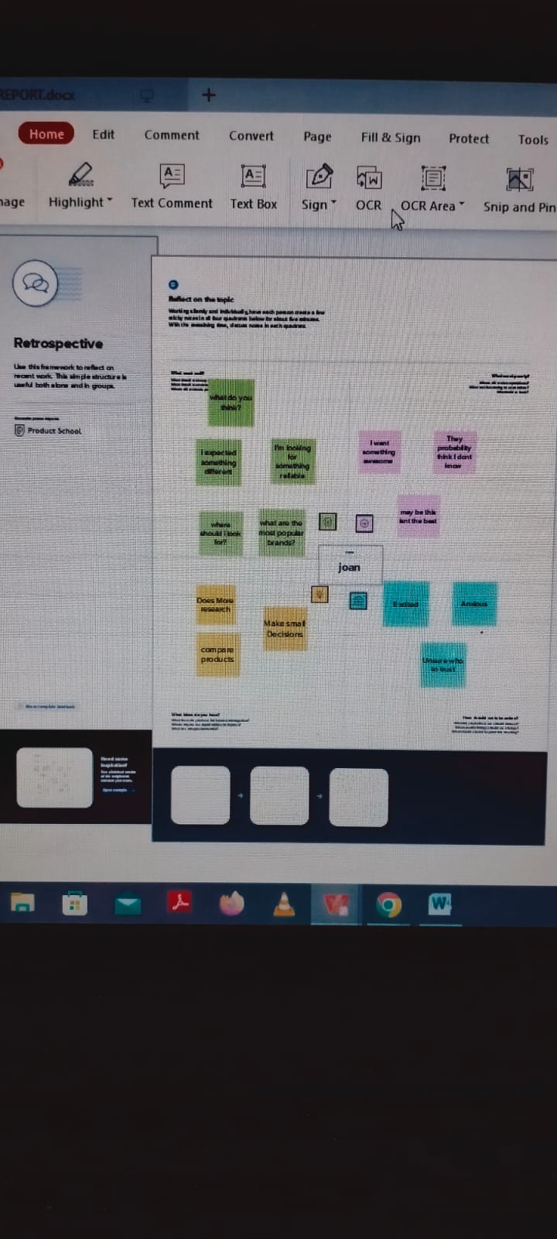

2.2 Ideation and Brainstorming map :

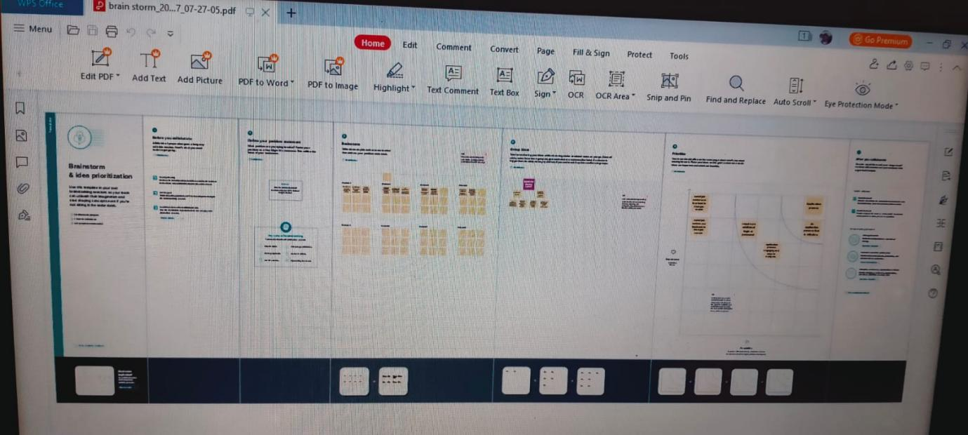

# **Result**

* 1. Data Model:

|  |  |  |
| --- | --- | --- |
| object | Field Label | Data |
| Recruiter | Record Name  Data Type  Format  Options features  Deployment status  status | Recruiter Name  Auto number  Rec-{00000}  Allow reports  Deployed  Allow search |
| Jobs | Record Name  Data type  Format  Options features  Deployment status  status | Jobs Name  Auto number  Rec-{0000}  Allow reports  Deployed  Allow search |
| candidate | Record Name  Data type  Format  Optional feature  Deployment status  status | Candidates name  Auto number  Rec-{0000}  Allow reports  Deployed  Allow search |
| Job application | Record name  Data type  Format  Optional features  Deployment status  status | Job applications name  Auto number  Rec-{0000}  Allow reports  Deployed  Allow search |
| Tabs | Record name  Data type  Format  Optional features  Deployment status  status | Tabs name  Auto number  Rec-{0000}  Allow reports  Deployed  Allow search |

* 1. Activity and screenshots

Milestone 1:

Creating Developer Account

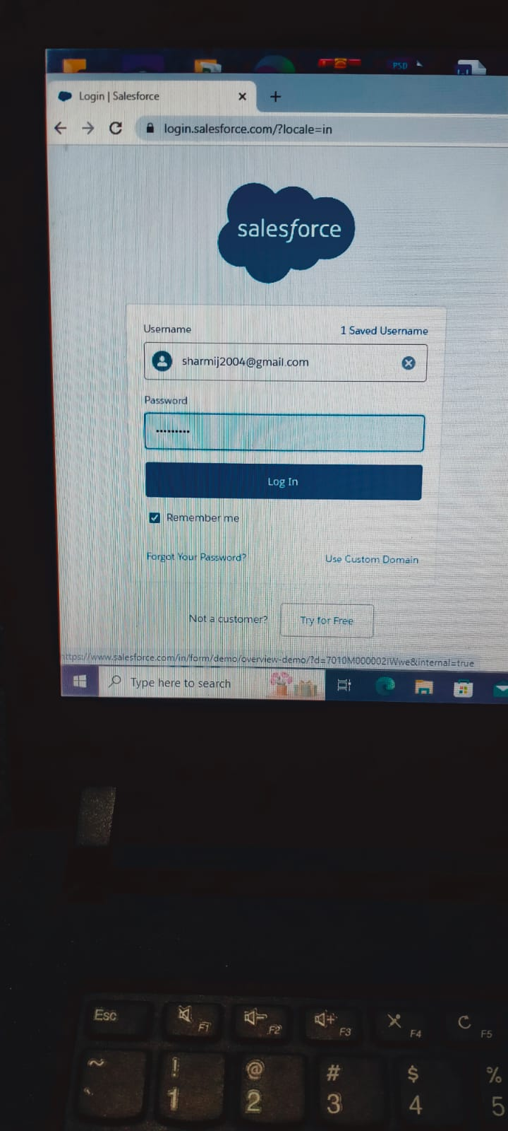

Milestone 2:

Activity 1- creation of object Recruiter, Jobs, Candidates, Job application & tabs.

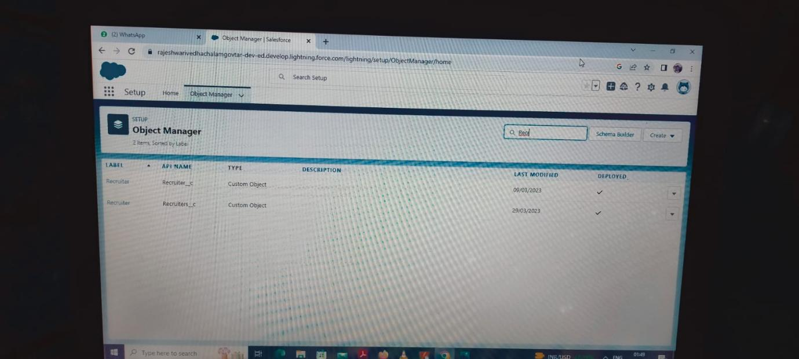

Milestone 3: Creation of Lightning app for Job Application.

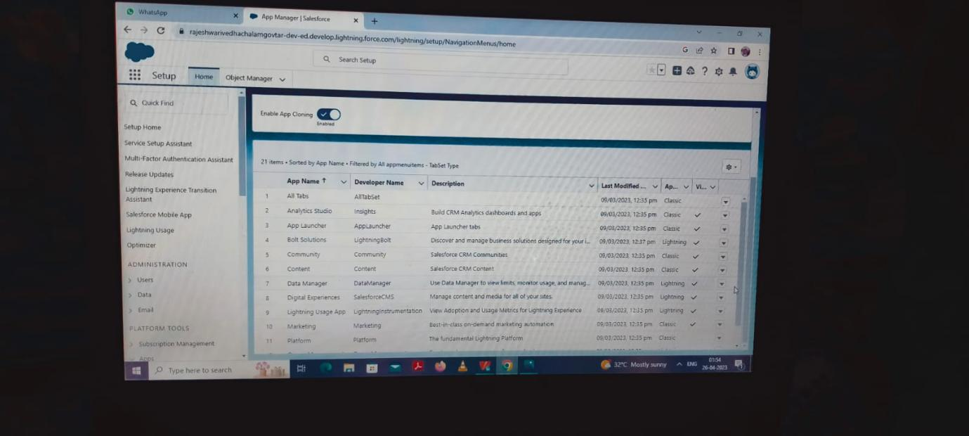

Milestone 4: Creation the fields for Recruiter, Jobs, Candidates, Job application & Tab.

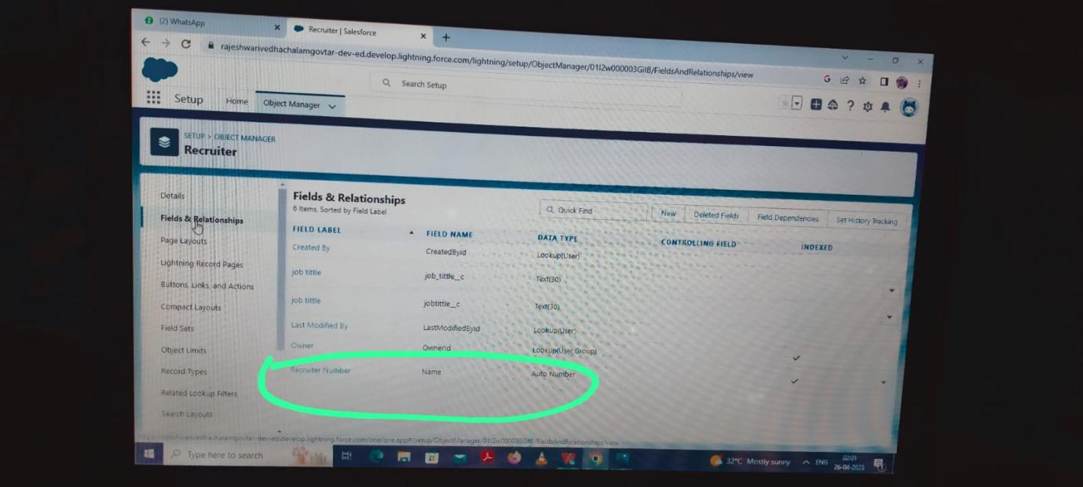

Milestone 5: Creation of Profile.

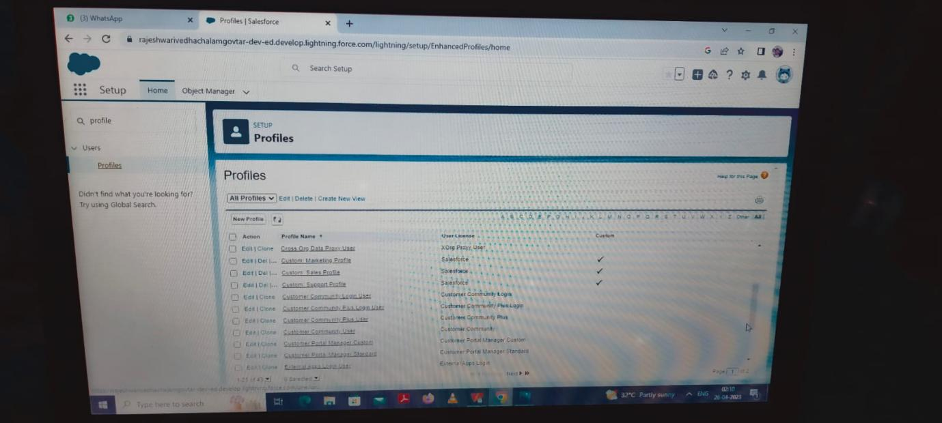

Milestone 6: Creation of User.

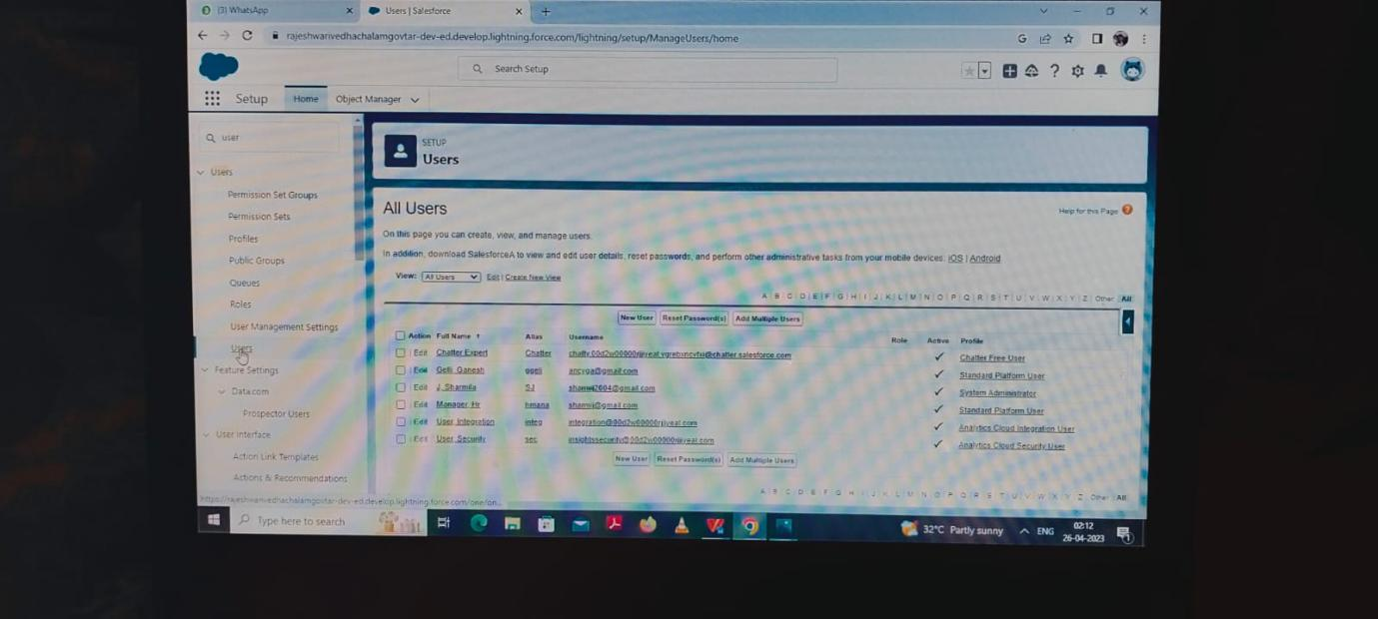

Milestone 7: Creation of Permission sets.

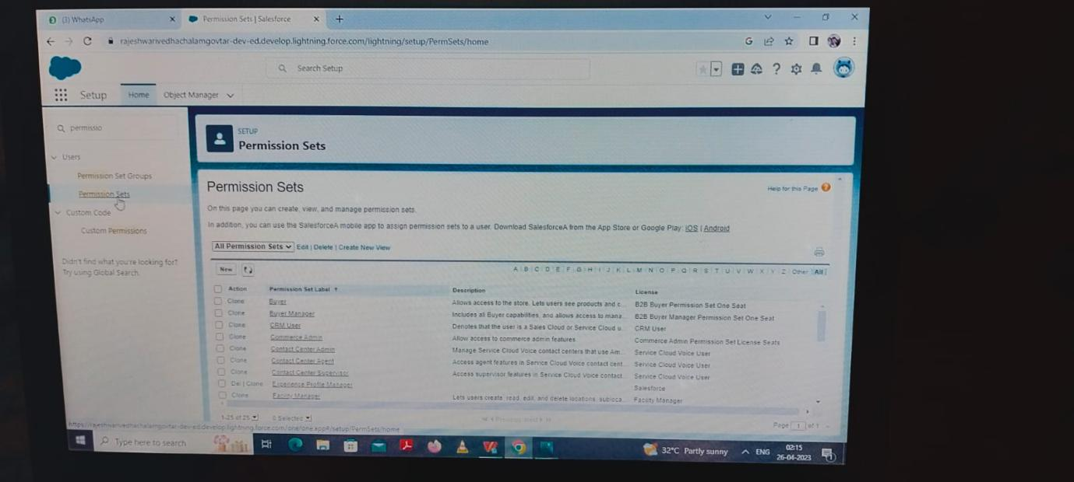

Milestone 8: Creation of Reports.

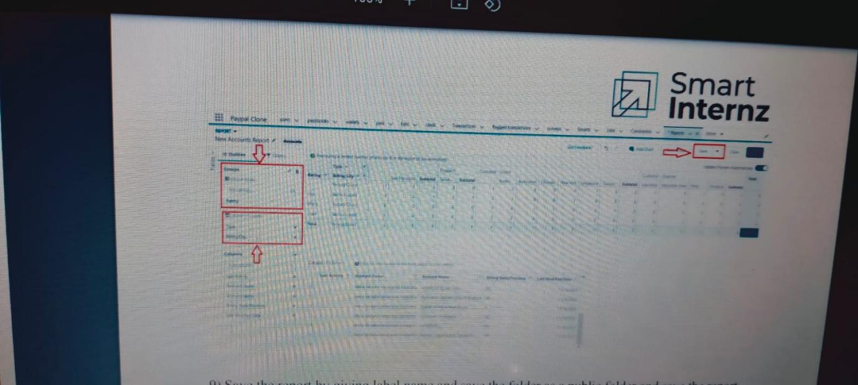

# Trailhead Profile Public URL :

Team member 1 :https://trailblazer.me/id/sharj40

Team member 2: https://trailblazer.me/id/punik4

# sAdvantages and Disadvantages :

In this Salesforce we are prepare a job application app for attending interviews and gathering customer details. And it is very useful to easily take over the level of gathering customer details, personal details and Etc…

# Application :

Our Apps is to be :

* All kinds of Job application,
* All types of Report collecting companies,
* Etc….

# CONCLUSION :

We are create the objects with the help of attending interviews and gathering personal details with the help of salesforce app. And also create App (job application ) with the help of salesforce. And then the objects are converted to Fields and then permission sets. Atlast Finished the creation of app.

# Future Scope :

Ability to create a App.